***Pressure Controller Project***

Mastering Embedded System Online Diploma

www.learn-in-depth.com

First Term (Final Project 1 )

Eng. Kareem Khaled Abdelazim Mohamed

My Profile:

<[kareem.khaled.azim@gmail.com (learn-in-depth-store.com)](https://www.learn-in-depth-store.com/certificate/kareem.khaled.azim%40gmail.com)>

***Design sequence:***

1. **Case study:**

A pressure controller that keep tarck of the pressure in the cabin and if it exceeds 20 bar it informs the crew using an alarm for 60 seconds

Keep track of the pressure readings

* Assumptions:
  + The system maintenance is not supported.
  + The pressure sensor never fails.
  + The alarm never fails.
  + The controller never faces a power cut-off.
  + The system setup and shutdown procedures are not modeled.
  + The power supply of the system is not modeled.

1. **Method:**

V-model method is used in this project.

1. A diagram of a computer network

   Description automatically generated with medium confidence**Requirement:**
2. **Space exploration**

It was found that using STM32 microcontroller with cortex-M3 processor will suit the requirements of the system the best

1. **System analysis:**
   1. **Use-Case diagram:**

* 1. **Activity diagram:**

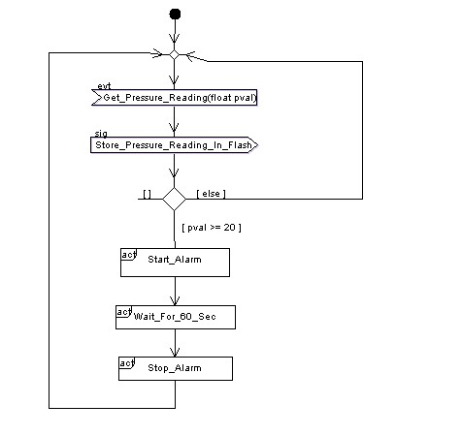

* 1. **Sequence diagram:**

1. **System Design**

* **Pressure sensor state diagram:**

* **Main algorithm state diagram:**

* 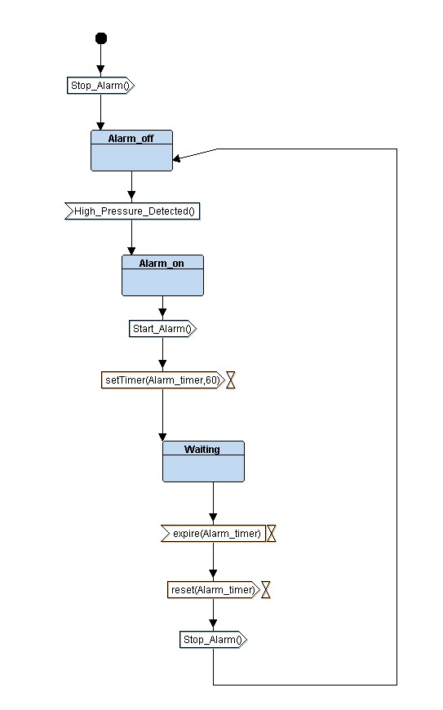**Alarm monitor state diagram:**
* **Alarm actuator state diagram:**
* A diagram of a system

  Description automatically generated

***Logic simulation and verification:***

Whole trace:

***Code screenshots:***

* **A screenshot of a computer program

  Description automatically generatedA screenshot of a computer program

  Description automatically generated*Pressure sensor driver:***
* ***Main Algorithm:***

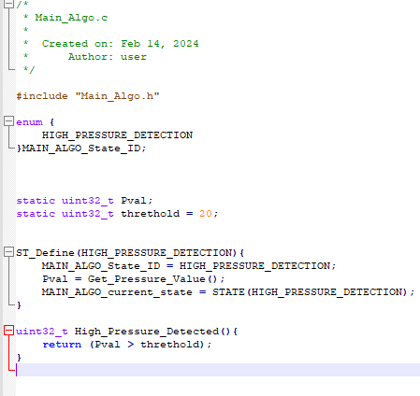

* ***A screenshot of a computer program

  Description automatically generatedA screenshot of a computer program

  Description automatically generatedAlarm actuator:***
* ***A screenshot of a computer program

  Description automatically generatedA screenshot of a computer program

  Description automatically generatedAlarm monitor:***
* ***State.h***

* ***A screenshot of a computer program

  Description automatically generatedA screenshot of a computer program

  Description automatically generatedDriver:***
* ***Main:***

* ***Startup:***

* ***LinkerScript:***

* ***MakeFile:***

* ***A screenshot of a computer program

  Description automatically generatedMap file:***

* ***Headers and sections:***

* ***Simulation results:***

The sensor reading in this case is 14 bar which is under the threshold determined by the user so no alarm is produced.

The sensor reading in this case is 30 bar which is under the threshold determined by the user so no alarm is produced.